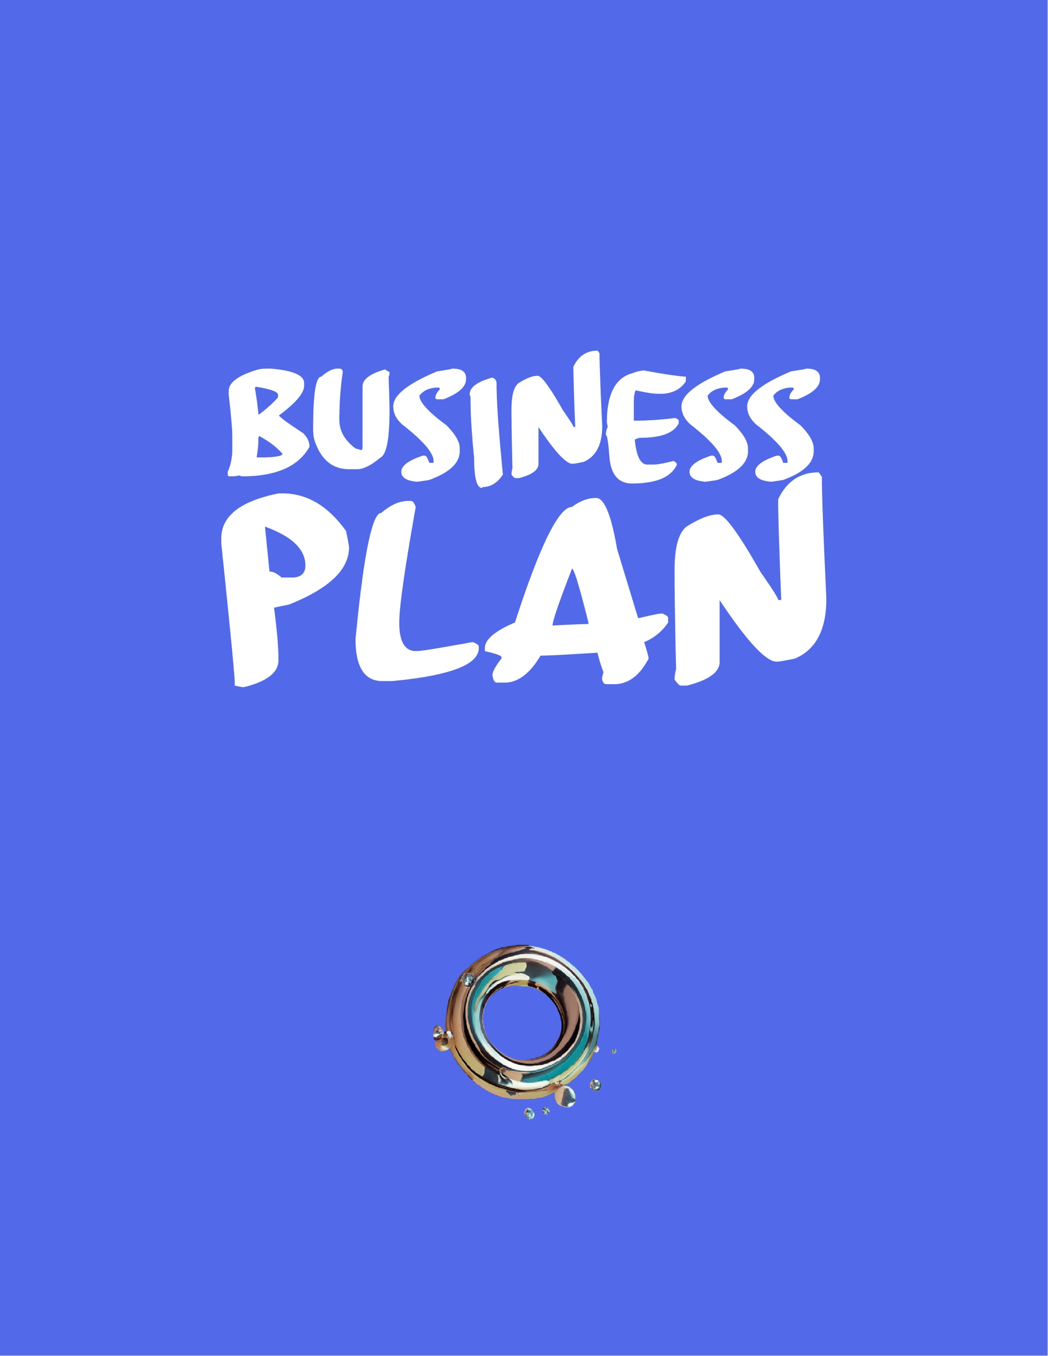

**Simple Business Plan Template Instructions:**

● Replace copy in the **[ ]** with information and details about your business.

● Delete template **\*\*instructions\*\*** as you complete each section.

# 

# 

# [Your Business Name Here] [logo]



The executive summary introduces the plan, but it is written last. It provides a concise and optimistic overview of your business and should capture the reader's attention and create a desire to learn more. The executive summary should be no more than two pages long, with highlights or brief summaries of other sections of the plan.3

* **Mission statement** — Clearly state the purpose of your business and the specific nee it addresses. Highlight the unique value proposition and vision for the future.
* **Company overview** — Provide a brief yet detailed description of your company, including it’s size, location, key management team and ownership structure.
* **Products/Services** — Describe your main product(s) and/or service(s).
* **Target Market** —Identify the customer base you plan to target and how your business will serve those customers.
* **Competitive Advantage** — Summarize the competition and how you will get market share. What is your competitive advantage?
* **Financial Projections** — Outline your financial projections for the first few years of operation.
* **Startup Financing Requirements** —State your startup financing requirements.

## 



### 2.1 Mission of [Your Business Name Here]

[Craft a brief “elevator pitch” ***vision or mission*** statement about your business that answers the following five questions]

* **What does [your business] do?** [Are you selling products, services, information or a combination?]
* **Where does this happen?** [Will you conduct business online, in-store, via mobile means or in a specific location or environment?]
* **Who does [your business] benefit?** [Who is your target market and ideal customer for your concept?]
* **Why would potential customers care?** [What would make your ideal customers take notice of your business?]
* **How does [your products and/or services] outshine the competition?** [What your value proposition that would make customers choose you over a competitor?]

**If you get stuck, continue brainstorming ideas for other parts of your plan, then complete this section.**

### 2.2 Vision Statement

* Short-term Goals — [outline in detail]
* Mid-term Goals — [outline in detail]
* Long-term Goals — [outline in detail]

### 2.3 Offer and Value Proposition

[Detail your ***offer(s)***, which are the products and/or services you plan to sell. Include a ***value proposition*** for each, which is a statement of how your product or service solves a problem for target customers.]

## 



### 3.1 Target Market and Size

[Define the target market(s) for your products/services.]

* Explain the need for your products/services.
* Estimate the overall size of the market and the units of your products/services that the target market might buy. Include forecasts of potential repeat-purchase volume and how the market might be affected by economic or demographic changes.
* Estimate the volume and value of your sales in comparison with any existing competitors. Highlight any key strengths over the competition in easily digestible charts and tables. (Show evidence of customer demand).
* Describe any helpful barriers to entry that may protect your business from competition, such as access to capital, technology, regulations, employee skill sets, or location.

### 3.2 Competitor Profiling

**Competitor Matrix:** *\*\*Depending on your industry and offering\*\**

|  |  |  |  |  |
| --- | --- | --- | --- | --- |
| **Aspect** | **Competitor 1** | **Competitor 2** | **Competitor 3** | **Competitor 4** |
| Pricing |  |  |  |  |
| Ease of use |  |  |  |  |
| Market Share |  |  |  |  |
| Community |  |  |  |  |
| Integrations |  |  |  |  |
| Mobile Apps |  |  |  |  |
| Reliability |  |  |  |  |

### 3.3 Potential Gaps

* [Potential Gap 1]
* [Potential Gap 2]
* [Potential Gap 3]

### 3.4 Audience Research and Ideal Customer

[Describe your ***ideal customer*** and explore a potential ***broader audience*** for your products and/or services.]

### 3.5 SWOT Analysis

[Strengths]



[Weaknesses]



[Opportunities]



[Threats]



## 

### 

### 4.1 Revenue Streams

**Using the lists below, select the ***revenue streams*** that your business will use to make money and the ***sales channels*** and ***marketing vehicles*** that will connect you to customers.**

**Revenue Streams:** **check how your business will earn income; edit as needed**

○ **Product sales:** Online, mobile, wholesale and in-store sales.

○ **Affiliate income:** Monetize blog and social media posts with affiliate links.

○ **Advertising income:** Reserve website space for advertising.

○ **E-book sales:** Publish e-books related to [your business niche].

○ **Video income:** Monetize a YouTube channel related to [your business niche].

○ **Webinars and online classes:** Monetize coaching-style webinars and online classes related to [your business niche].

○ **Members-only content:** Monetize a members-only section of the website for specialty content related to [your business niche].

○ **Franchise:** Monetize [your business] model concept and sell to franchise entrepreneurs.

4.2 Sales Channels

**Direct Sales Channels:** **check how your business will transact sales; edit as needed**

○ **Mobile point-of-sale (POS):** Mobile and remote sales that don’t happen in-store.

○ **Brick-and-mortar location:** In-store sales in a standalone location.

○ **E-commerce platform:** An online store on an e-commerce platform.

○ **Social media channels:** Facebook, Instagram, Pinterest shoppable posts/pins.

○ **Sales representatives:** For wholesale or other rep-driven sales.

**Other Income Channels:** **check how your business can make other income; edit as needed**

○ **Affiliate income:** Blogging or web content with affiliate link commissions.

○ **Advertising income:** Reserved advertising spaces on [your business] website.

○ **E-book sales:** E-book sales via Amazon Kindle Direct Publisher.

○ **Video income:** YouTube channel with ad monetization.

○ **Webinars and online classes:** Online subscription classes and webinars.

○ **Members-only content:** Password-protected content on the website or blog.

### 

### 4.3 Marketing

**Marketing and Advertising:** **check how your business will reach audiences; edit as needed**

**Online Marketing Methods:**

○ Informative blog content

○ Online landing page sales funnels

○ Social media via Facebook, Instagram, LinkedIn, TikTok, Pinterest, Twitter, other

○ Video content on YouTube, Facebook or other

○ Free e-books for marketing and lead generation

○ Paid online advertising via Google AdSense or other networks

○ Email and/or SMS marketing

○ Customer loyalty program

**Traditional Advertising and Public Relations Outlets**

○ Radio

○ Television

○ Newspaper

○ Magazine

○ Direct mail

○ Doorhanger flyer distribution

○ Event and team sponsorships

## 



### 5.1 Structure, Suppliers and Operations

**Detail the ***structure*** and ***operational overview*** for your business.**

* **Business structure:** [Sole Proprietorship, Limited-liability Company, Partnership, Corporation, etc.
* **Permits:** [Required city, county and state permits to operate.]
* **Education or certifications:** [Required licenses, certifications or education to operate.]
* **Standard operating procedures (SOPs):** [Overview of day-to-day operational plans.]
* **Supply chain:** [Raw good or resale/wholesale product suppliers and ordering processes.]

### 5.2 Management Team Profiles

* **Management team**: Describe managers and their roles, key employee positions, and how each will be compensated. Include brief résumés.
* **External resources and services**:List any external professional resources required, such as accountants, lawyers, or consultants.
* **Human resources**:List the type and number of employees or contractors you will need, and estimate the salary and benefit costs of each.
* **Advisory board**: Include an advisory board as a supplemental management resource, if applicable.

## 

### 

### 6.1 Start Up Operations

* **Development**:Explain what you have done to date to identify possible locations, sources of equipment, supply chains, and other relevant relationships. Describe your production workflow.
* **Production**:Explain how long it takes to produce a unit/deliver a solution and when you'll be ready to start operations. Include factors that may affect the time frame of production and how you'll deal with potential problems, such as rush orders.
* **Facilities**:Describe the physical location of the business (if needed).
* **Staffing**:Outline expected staffing needs and the main duties of staff members, especially the key employees. Describe how the employees will be sourced and the employment relationship (i.e., contract, full-time, part-time) as well as any training needs and how these will be provided.
* **Equipment**:Include a list of any specialized equipment needed, along with cost, whether it will be leased or purchased, and sources.
* **Supplies**:If your business is, for example, manufacturing, retail, or food services, include a description of the materials needed, reliable sources, major suppliers, and how you will manage inventory.

### 6.2 Operation Cycle

[Create a timeline from first meeting/pitch to delivery or product/service]

1. [Pre Qualifying the lead]
2. [Introduction - Defining Value]
3. [Discovery Meetings]
4. [Solution Proposal]
5. [Closing Sale]
6. [Communication]
7. [Presentation]
8. [After Care]

### 6.2 Fees Structure

**Explain business model for selling products or services, including payment schedules, hourly rates, recurring revenue, upselling options**

### 

### 7.1 Start Up Costs

**Cost Forecast** **enter estimated startup and ongoing costs; edit table as needed**

|  |  |  |  |
| --- | --- | --- | --- |
| **Business Need** | **Startup Cost** | **Ongoing Cost** | **Source/Supplier** |
| Legal and administrative costs | $ | $ |  |
| Webhosting and E-commerce website | $ | $ |  |
| Inventory | $ | $ |  |
| Marketing social media advertising | $ | $ |  |
| Payment processing | $ | $ |  |

### 7.2 Sales Forecasts

**Gross Profit Projections**

**Use product research to estimate retail prices for your goods and/or services, then subtract cost-of-goods (raw material, hourly rate or wholesale costs) to estimate gross profits. Edit table as needed.**

|  |  |  |  |  |  |  |  |  |  |  |  |  |
| --- | --- | --- | --- | --- | --- | --- | --- | --- | --- | --- | --- | --- |
| **Product or Service** | **JAN** | **FEB** | **MAR** | **APR** | **MAY** | **JUN** | **JUL** | **AUG** | **SEP** | **OCT** | **NOV** | **DEC** |
| Project amount | $ | $ | $ | $ | $ | $ | $ | $ | $ | $ | $ | $ |
| Renewables | $ | $ | $ | $ | $ | $ | $ | $ | $ | $ | $ | $ |
| SLA | $ | $ | $ | $ | $ | $ | $ | $ | $ | $ | $ | $ |

### 

### 7.3 Cash-flow Forecasts

|  |  |  |  |  |  |  |  |  |  |  |  |  |
| --- | --- | --- | --- | --- | --- | --- | --- | --- | --- | --- | --- | --- |
| **Product or Service** | **JAN** | **FEB** | **MAR** | **APR** | **MAY** | **JUN** | **JUL** | **AUG** | **SEP** | **OCT** | **NOV** | **DEC** |
| VAT | $ | $ | $ | $ | $ | $ | $ | $ | $ | $ | $ | $ |
| Salary | $ | $ | $ | $ | $ | $ | $ | $ | $ | $ | $ | $ |
| SLA | $ | $ | $ | $ | $ | $ | $ | $ | $ | $ | $ | $ |
| Deductions |  |  |  |  |  |  |  |  |  |  |  |  |
| Rent |  |  |  |  |  |  |  |  |  |  |  |  |
| Education |  |  |  |  |  |  |  |  |  |  |  |  |
| Other |  |  |  |  |  |  |  |  |  |  |  |  |



* Financial graphs/ charts
* References
* Market research analysis